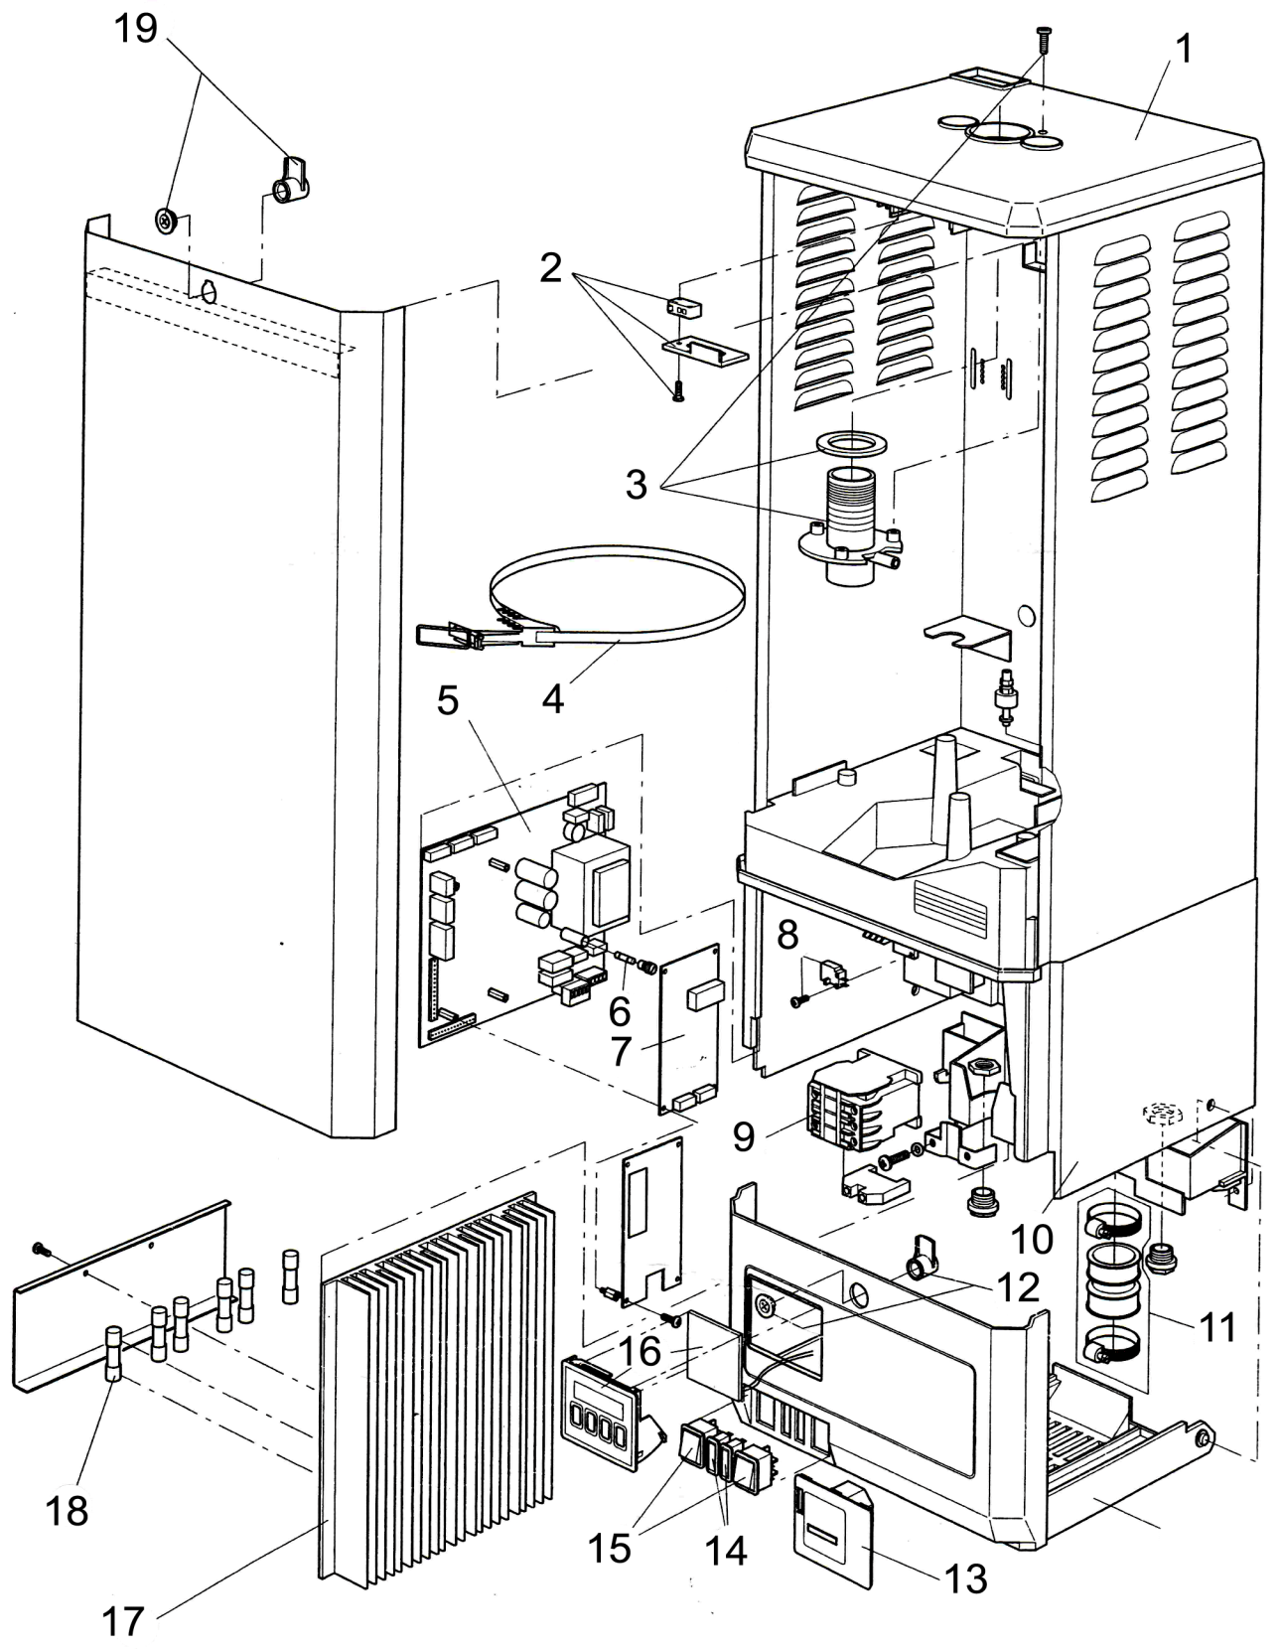
Condair MK4

No | Model | Item No | Description
1-12 | All | No longer available
13 | All | DF220066 | Running time meter
14-19 | All | No longer available

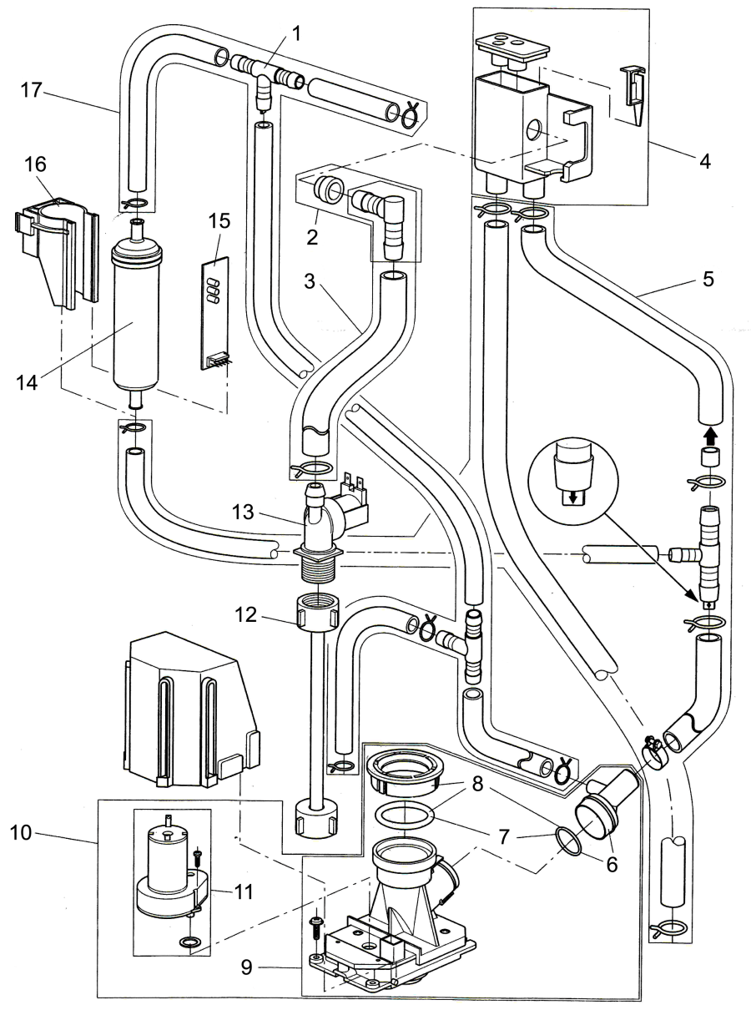
No | Model | Item No | Description
1-2 | All | No longer available
3 | All | DF201450 | Filling Hose Set ST/IT
4 | All | DF220059 | Filling Cup Cpl
5 | All | DF201452 | Water Inlet Hose Set ST/IT
6 | All | DF302614 | T-Piece Set
7 | All | DF220062 | Gasket Drain Valve Set
8-9 | All | No longer available
10 | All | DF203439 | Drain Valve Assy Complete
11 | All | DF220063 | Gear Motor
12 | All | DF1103857 | PEX-Hose
13-14 | All | No longer available
15 | All | DF203496 | Float Level Unit PCB
16 | All | DF1114754 | Float Holder
17 | All | DF201451 | Condensate Hose Set ST/IT

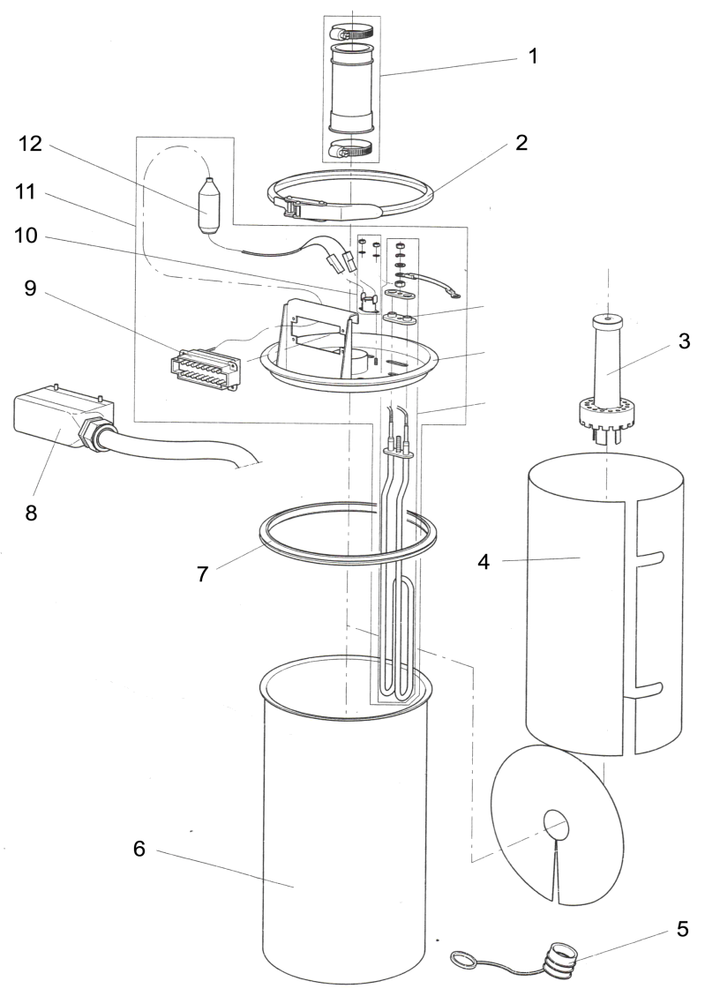
No | Model | Item No | Description
1 | All | DF220053 | Steam outlet hose cpl
2 | 5/10kg | DF220051 | Cover Clamping Ring
2 | 20/30kg | DF1103814 | Cover Clamping Ring
3 | All | DF223520 | Steam cylinder strainer*
3 | All | DF222569 | Steam cylinder strainer for mixed water*
4 | 5/10kg | DF203426 | Scale collector foil*
4 | 20/30kg | DF203427 | Scale collector foil*
5-6 | All | No longer available
7 | 5/10kg | DF1101516 | Gasket*
7 | 20/30kg | DF1100966 | Gasket*
8 | All | No longer available
9 | 5kg | DF220055 | Connector
9 | 10/20kg | DF220056 | Connector
9 | 30kg | DF1103832 | Connector
10 | All | DF1103822 | Thermostat cpl
*Consumable items recommended to be kept on site. Standard 2-3 day Mainland UK delivery is charged at 3% order value subject to minimum charge of £30. Overseas delivery £POA

